**ECE 212: Sprint Review, Retrospective & Planning report for team _4_ (name)**

Jana, Zhang, Gabrielle, Garth, (read the instructions about content of this report first)

# **Sprint Review**

## Previous Sprint Goal

we plan on adding an alarm to remind users when they need to wash their hands, as well as a sensor that will sense when the user begins to wash their hands and will begin a 20 second countdown timer, indicating how long the user should wash their hands for. This will be indicated by an LED that will turn on for 20 seconds or blink 20 times for 1 second intervals.

## Sprint Backlog Status

|  |  |
| --- | --- |
| **Sprint Backlog items DONE** (numbered list) | 1. *Find Vibration sensor* 2. *programming the app that will sync to the watch* 3. *programming the bluetooth module* 4. *Program countdown timer* 5. *program the alarm and button control* |

|  |  |  |
| --- | --- | --- |
| **Sprint Backlog items NOT DONE** | **Reason for NOT DONE** | **Keep in backlog (Y/N); why?** |
| 1. *coding the vibration sensor* | 1. *Did not decide which vibration sensor to use until towards the end of the sprint* | 1. *Yes; this will allow the user to restart the timer* |
| *4. Complete Build of watch prototype* | *5. Circumstances beyond control; we did not know that all the components ordered arrived until towards the end of the sprint* | *6. Yes, Needed in order to test the circuit* |
| *7. LCD clock display* | *8. we did not know that all the components ordered arrived until towards the end of the sprint.Besides,according to test,the library of lcd not correct* | *9.yes, LCD clock display is our basic of the project. This is also a very important feature of our project.* |

## Full Product Backlog Pruning

From the full backlog view, we have finished most items in sprint1 and sprint 2. Creating the code for the RTC 24 hour clock and adding the option of the 12 hour clock of the watch ,which can Realize the time display function of the watch.Besides, we have finished a lot of functions of programming work. For example, in order to let users know when they need to wash their hands, we programmed the function of alarm which can set a time and use a buzzer and led lighting to remind them. Meanwhile, we added the countdown timer to remind users when the time of washing hands is over.And programming the bluetooth to collect the data,which will help us to analyze how often they are washing hands everyday and the efficiency they are. Due to express delivery failure,we just got all the components this thursday. So we do not have enough time to finish building the circuit and test hardware this week. This is exactly what we need to continue to do for the next sprint 3.We also plan to program the function of vibration sensors in the next sprint. In addition, we will focus on testing the functions which we have finished programming like LCD clock display, alarm and button control, bluetooth and app which will sync to the watch.

For a better user experience, we add 3 items in the backlog. First is we add an app which can Sync with the watch via smartphone. In this way, the user can observe the data collected by Bluetooth through the mobile phone, which can also better remind the user whether the time and frequency of hand washing should be changed,the efficiency they are. Second one is we add the function of alarm, Which users can freely set the reminder time to wash their hands.It is worth mentioning that this alarm clock function is based on the real time clock function, so there is no need to worry about resetting the time due to power cut. The last one is we add different buttons to control the function conversion. It means the user can use buttons to finnish 24 clock display to 12 clock LCD display, 12 clock display to 24 clock LCD display,set time of alarm, If there are new functions in the future, we can still change the button control function.

Full product backlog

* Test 24 /12 clock LCD display
  + successfully connect circuit
  + check the library of rtc and new LCD
  + check the library of nano
  + test code on arduino
  + successful print the time of 24/12 clock to screen
* Wire up prototype on breadboard
  + Get all parts in mail Place parts on a breadboard or mounting board.
  + Test part individually
  + Connect all parts to Nano in one circuit
  + Let the team know that we are ready to start testing code.
* test alarm and button control
  + test the circuit after connecting the buttons and RTC
  + Setup function to accept a time variable, and output it to the screen.
  + test the function of button control
  + test if the alarm can set time or not
  + test when the time to we setting, if buzzer have sound and led will led
* programming sensor function
  + find the correct sensor library
  + Look up how to do functions in arduino
  + Make sure that we can read a signal from the sensor
  + test it on software using arduino
* test bluetooth system app on prototype
  + test hardware of bluetooth module
  + test if bluetooth can connect the watch via phone
  + test the function of collecting data by bluetooth
  + test if app works well or not
  + test the circuit after connecting the bluetooth

## Notable technical accomplishments

* programming the 12 hour clock
* programming the app
* programming the countdown timer
* Programming the Bluetooth module

## Technical and other difficulties

The most technical difficulty was using my sketch “Blink1.ino” which worked fine on the Arduino Uno and the computer using Windows recognized port COM 5. When I restarted the IDE with the same sketch when it is connected to the Arduino Nano, I only saw in a box “Serial port COM 5” greyed out but no confirmation the Nano is recognized. I began troubleshooting by triple checking the correct board and port selected. Pressing the reset button before upload begins and before compiling. Plugging the board into different USB ports and uninstalling/reinstalling the FTDI drivers on each USB port. That helped resolve the problem.

Non-technical difficulty was having a team member having to deal with an urgent family matter which delayed the testing and wiring of the prototype. Teammember needed to head out of town to resolve urgent family matters. Another team member stepped up to help out to decrease the delaying time of the project. Also making a final decision on determining which sensor to use for detecting hand washing, the part was ordered and expected to arrive on Monday, August 3rd.

### (optional) Technical items that could be improved and suggested improvements

* + Use more communication methods such as google hangout more often for efficient communication
  + having scheduled meetings to improve communication, as well as letting team members know if they can or cannot make it to a meeting and let everyone know what they are working on and if they need assistance

## New Skills

Couple of sentences for each team member: Briefly discuss what new skills you learned during this sprint. Give this information for each team member. Leave empty if nothing new learned.

Team member #1 - Jana: A new skill that I required is learning more about programming the arduino as well as learning how to program different components.

Team member #2: Zhang First, I have learned how to use a real time clock to finnish the function of the alarm. Second, I learned some programming skills,how to check the library using correct or not, how to find the problems of your code and debugging them more quickly . Finally, I also learned how to use different buttons to control different components.

Team member #3: Gabrielle: I have learned how to use MIT app inventor and how to build code using this app creator, and how to create a bluetooth connection between a phone and an arduino using the app and a bluetooth module chip.

Team member #4: Garth: I learned how to troubleshoot problems using a checklist with uploading an IDE to the Arduino Nano and reinstalling the device driver to recognize port COM 5 to microcontroller using Windows 10.

# **Sprint Retrospective**

For this sprint, we primarily used our trello board for keeping track of all the work to be done and how much progress has been made. We also used google hangouts for more efficient communication purposes as well as discussing final decisions for the project such as what parts we should use, design ideas for the case, and coding help. We also created a Bill of Materials to keep track of all the items we would need, and the information needed for purchasing those items.

## Teamwork and planning - things that went well

* good use of the tello board
* Decent communication using google hangouts
* Partial goals achieved and plans improved

## Teamwork and planning - things that could be improved and suggested improvements

* Communication and scheduling planned meetings outside of class
* Managing deadlines
* Delegation of tasks should be clearer

## Trello

## (describe how you will utilize Trello better. One paragraph, as needed)

We will utilize trello better by setting realistic goals and deadlines that reflect where we currently are in the project. In addition to this, we will move cards around to where they need to be based on where we are in the project to reflect the progress we are making towards completing the project.

At the same time, we will also check trello after finishing the work, and write necessary comments and opinions on this task on it, which greatly improves our work efficiency and increases the effectiveness of communication.

## Trello Screenshot

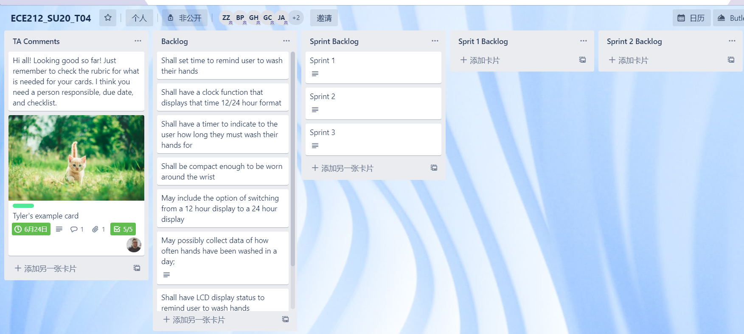

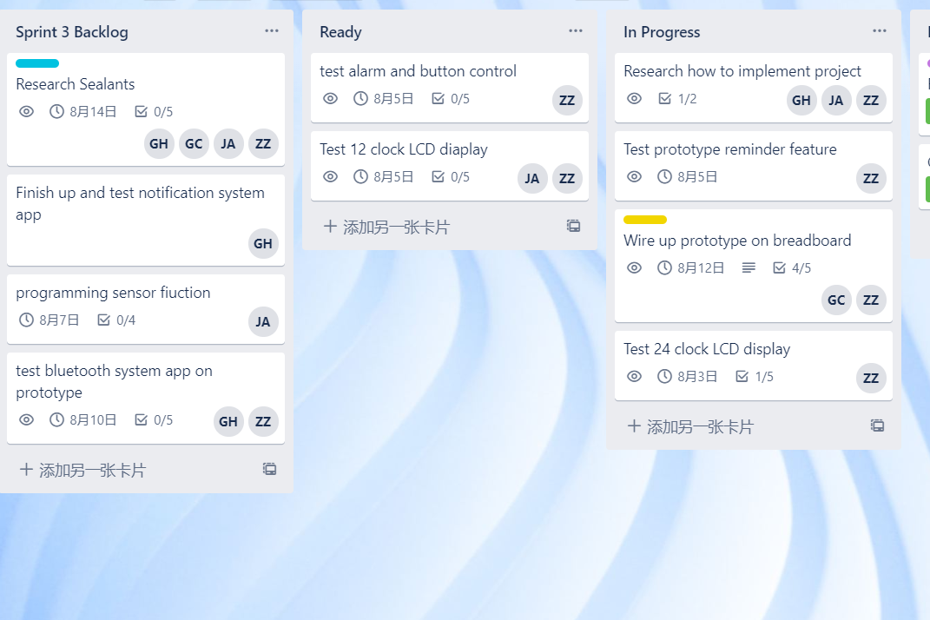

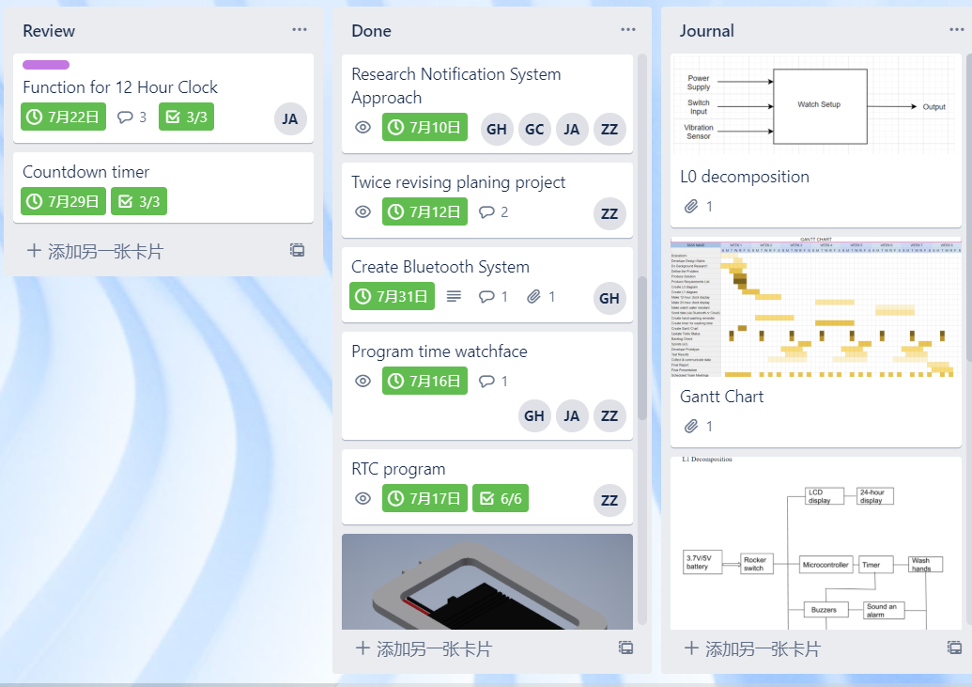

Overall, we would give ourselves a score of 3.5 (out of 5) for how well this sprint went.

# **Next Sprint Planning**

## Overall project plan

Our plan is to create a basic watch with smart features that will help upkeep good hygiene techniques as well as send other reminders to the user.

### New Gantt Chart

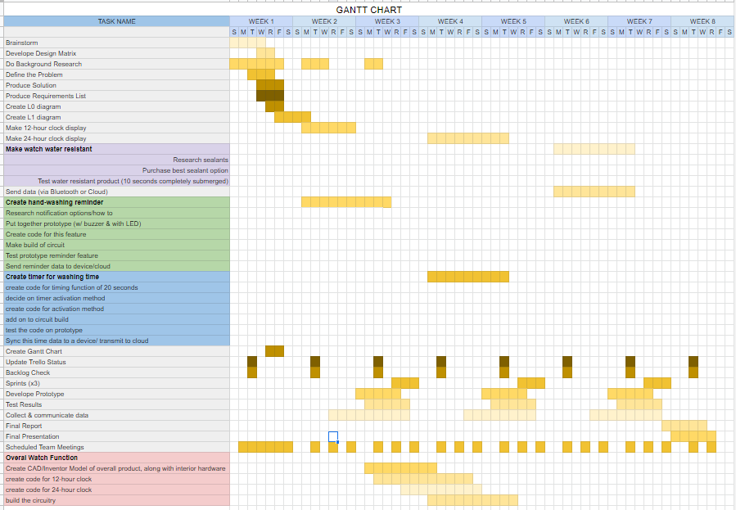

### Overall Plan Changes

Garth passed along the prototype to Zhang to continue working on and begin inputting the code into the arduino to test the prototype that will be built. We have also changed what we will be focusing on for this coming sprint due to time constraints, and circumstances beyond our control to reflect the work that has been completed in the previous sprints. We also completed some sections that were previously assigned to this upcoming sprint in the previous sprint. We will mainly be focusing on debugging the code and building a functioning prototype of the watch.

### Requirements

* Shall set time to remind user to wash hands
* shall have a clock function that displays the time in a 12/24 hour format
* shall have a timer to indicate how long the user should wash their hands for
* shall be compact enough to be worn as watch
* may include the option of switching from a 12 hour format to a 24 hour display
* may include application that connections via bluetooth to android device
* may collect data of how often hands have been washed in a day
* may have a buzzer or a vibration sensor to sense movement of the user/ indicate hand washing motion

### Functional decomposition

there are currently no changes made for the L0 and L1 decomposition

## Next Sprint Details

### Next Sprint Goal

* look up how to do/setup functions in arduino
  + sensor function
  + bluetooth function
  + notification system
* Print time to screen
  + set up functions to accept time variable and output it to the screen
  + finnish 12/24 clock function
* finish the vibration sensor function
  + Make sure we can read signal from the sensor
  + Make sure sensor can successfully detect vibration variable
  + finnish the programing of vibration sensor
* debug code
  + 12/24 clock LCD display
  + alarm and button control
  + countdown timer
* test and debug the application and bluetooth connection from phone to prototype
  + test 12/24 clock LCD display
  + test alarm and button control
  + test countdown timer
  + test bluetooth connection and bluetooth hardware
  + test the app of bluetooth
  + test the vibration sensor when it finished.
* finish building circuit
  + connect the bluetooth
  + connect the RTC
  + connect LCD
  + connect the buttons
  + solder the component aboves together
* possibly make a 2.0 version of the watch enclosure to fit any new components being added

### Priorities & Responsibilities

Our highest priority is to finish building the prototype in order to move forward with debugging the code. This is a critical step for the project as we have not been able to properly test the code we have written and do not know if the product works. Zhang has taken over building the circuit and will begin to compile the code once he completes building the watch, with assistance from Jana and Gabrielle when needed. Jana and Gabrielle will continue to program the remaining portions of the project where Jana will focus on programming the vibration sensor and Gabrielle will complete working on the bluetooth module and connecting it to the application. Jana and Gabrielle will help Zhang with building the circuit when and if needed. Zhang, Jana, and Gbarielle will debug their sections of code if needed.

### Test Plans

Once we complete building the circuit prototype, we will move on to testing the code for functionality and outline and issues we may run into while testing the program files. From here we will debug the code and continue testing the program until we have a working build.

### New Trello Board

We created the sprint 3 backlog and moved the items that needed to continue working on sprint 1 and sprint 2 to sprint 3. We reassigned the tasks and modified the deadline and the checklist of cards.

Our team T04 met with our Scrum Master Tyler Hull on July 31. We discussed Sprint Planning. All team members have read this report and agree that it accurately describes our discussion.